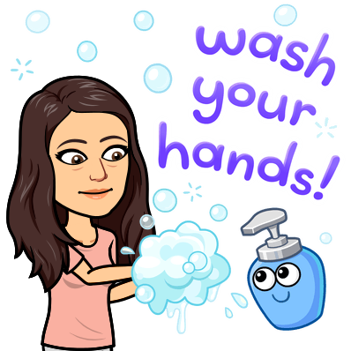
US Honors Living Primary Source Document
Teacher name: _____________________
Student name: _____________________
History is happening right now!
Covid-19- Corona Virus Disease 2019 is history in the making and you are a part of it.

Assignment: I’d like you to write about your experience with what is going on. Think of it like our Bell Work.

Just imagine one day being able to look back on your writing and share it with your children or grandchildren! Imagine your writing being used as a primary source document about the Corona Virus of 2020!
*Write as much or as little as you’d like. (I recommend 5 sentences)
*Be honest. No one will read this except for me.
*Your opinion matters because YOU MATTER! There is no such thing as a wrong opinion as long as you can explain it.

#1 START: April 13th, 2020 DUE: APRIL 17TH, 2020
Where were you when you first found out that school would be cancelled for over a month? How did you feel about this? Were you excited or upset? How has your life been affected the past few days? What questions do you still have?

Ms. Crook’s Entry Example:
I was sitting at home when I received an email from Principal Epting about this news. I was overwhelmed and saddened. I knew I was going to miss seeing you all, experiencing the learning process. You guys make me laugh, even on the days you make me want to pull my hair out. I’ve been trying to make assignments that I still think will benefit you guys but not be too overwhelming. I haven’t been able to go to the gym but I’ve been trying to work out from home. I am still wondering how we move on from here. When the next time I’ll get to see the rest of my family, and if our school will ever come back.

