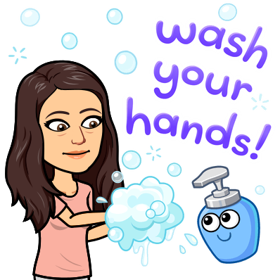
Teacher name: _____________________
Student name: _____________________
History is happening right now!
Covid-19 Corona VIrus Disease 2019 is history in the making and you are a part of it.

Assignment: I’d like you to write about your experience with what is going on. Think of it like our Bell Work.

Just imagine one day being able to look back on your writing and share it with your children or grandchildren! Imagine your writing being used as a primary source document about the Corona Virus of 2020!
*Write as much or as little as you’d like. (I recommend 5 sentences)
*Be honest. No one will read this except for me.
*Your opinion matters because YOU MATTER! There is no such thing as a wrong opinion as long as you can explain it.

#2 START: April 20th, 2020 DUE: APRIL 24TH, 2020
What is your prediction of what will happen in the coming weeks? Months? The rest of the year? How do you think this will affect students in the long run? Will people want to always learn online?

I am hoping that if we can flatten the curve by staying at home, we can get back to normal. It is interesting to see how the government is handling it. I think that if restrictions become to loose too quick, than we are going to have to go back on lock down, like it did in China. I like to think that you guys will want to go back to learning at school and having me there to help you all through the learning process. It has been hard for me to watch some of your struggle through this. I am also concerned for all of our mental health- BUT WE’LL ALL COME OUT OF THIS STRONGER TOGHETHER!!!!!! Miss you all.

