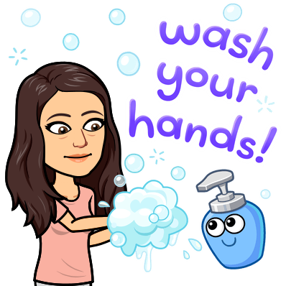
Teacher Name: _________________________
Student Name: _________________________
History is happening right now!
Covid-19 Corona Virus Disease 2019 is history in the making and you are a part of it.

Assignment: I’d like you to write about your experience with what is going on. Think of it like our Bell Work.

Just imagine one day being able to look back on your writing and share it with your children or grandchildren! Imagine your writing being used as a primary source document about the Corona Virus of 2020!
*Write as much or as little as you’d like. (I recommend 5 sentences)
*Be honest. No one will read this except for me.
*Your opinion matters because YOU MATTER! There is no such thing as a wrong opinion as long as you can explain it.

Week 3: Start: April 27th, 2020 Due: May 1st, 2020

What are you doing to keep yourself entertained while you are “social distancing” from others during this time? Do you have any hobbies at home, shows/ movies you are watching, games you are playing, ect…

Ms. Crook Entry:
I have been watching a lot of Netflix… I’ve been watching Tiger King, rewatching Gilmore Girls and the Office and Parks and Rec. I’ve also been watching Little Fires Everywhere. I watched Molly’s game the other night, which was very good and based on a true story. I am also going to start Mrs. America on Hulu. I have also been walking my dog a lot. I have also been learning Yoga. However, I did hurt my back and have had to take a break from the workouts. I’m going to start a puzzle this week also. Let me know what you guys are doing to keep buys.

