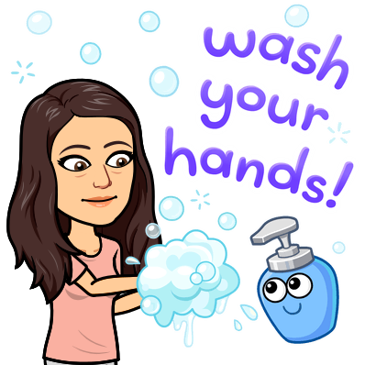
History is happening right now!
Covid-19 Corona VIrus Disease 2019 is history in the making and you are a part of it.

Assignment: I’d like you to write about your experience with what is going on. Think of it like our Bell Work.

Just imagine one day being able to look back on your writing and share it with your children or grandchildren! Imagine your writing being used as a primary source document about the Corona Virus of 2020!
*Write as much or as little as you’d like. (I recommend 5 sentences)
*Be honest. No one will read this except for me.
*Your opinion matters because YOU MATTER! There is no such thing as a wrong opinion as long as you can explain it.

Week 4: Start: May 4th, 2020 Due: May 8th, 2020
What do you do to stay informed? Social media, news, radio coverage, family members? Do you set boundaries so that you do not become too informed? Is it possible to be too informed? How are you doing mentally? Emotionally?

I personally was watching the news every day for a while to stay informed, but it became very hard for me to watch. It became draining and exhausting. Being constantly reminded of how we are to stay away from our loved ones was not good for my mental health. So now most of the time I get my news from the news app on my phone and different forms of social media. I have been doing better lately, especially knowing that the social distancing is coming to a close. However, remember to stay safe and keep your distance when you can. I want to continue knowing you are all staying safe.

