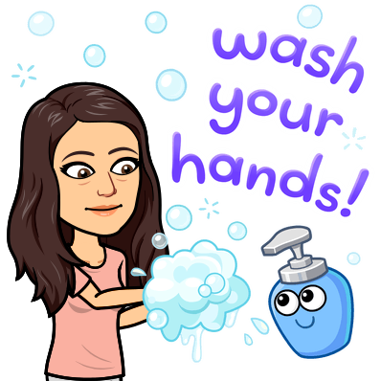
Teacher name: __________________
Student name: __________________
History is happening right now!
Covid-19 Corona Virus Disease 2019 is history in the making and you are a part of it.

Assignment: I’d like you to write about your experience with what is going on. Think of it like our Bell Work.

Just imagine one day being able to look back on your writing and share it with your children or grandchildren! Imagine your writing being used as a primary source document about the Corona Virus of 2020!
*Write as much or as little as you’d like. (I recommend 5 sentences)
*Be honest. No one will read this except for me.
*Your opinion matters because YOU MATTER! There is no such thing as a wrong opinion as long as you can explain it.

Week 5: Start: May 11th, 2020 DUE: May 15th, 2020

What has surprised you the most about this time of “distance learning”. Has it been good, bad, or somewhere inbetween? How will you spend your summer? Will it be different than the last couple months? Are you excited to go back to “real school” next year? What was your favorite part about history this year? What was your least favorite part? Would you say you like history or dislike it?

I’ve been surprised by how much you all have shared with me!! Although we have not been “together” I feel closer to some of you than ever before. I’m still missing seeing you guys, and it will never make up for our time lost with you all, but I have enjoyed the journals with you all. My time will probably not be much different than summer. My Hawaii trip has already been cancelled because of the virus. I have spent the last week in Orlando helping my brother and sister-in-law take care of their babies because they are also working full time from home as well with two babies under 2! We have had a lot of fun playing with them but they are TIRING. I am so excited to go back to school next year and see all your faces again!!!! Please let me know what you have liked (or not liked; nicely please) so that I can make things even better for next year! I have enjoyed you all so much this year, and wish the end of the year wasn’t robbed from us.

