US History

Week 1

Your Week at a Glance
 The Revolutionary Rise of Abolitionists
 The Wounded Knee Massacre

Name: Jane Ene

Teacher: Ms. Crook

Name: Jane Ene
Class: 3rd Period US History

The Revolutionary Rise of Abolitionists
By USHistory.org 2016
The American Revolutionary War marked the moment that the thirteen colonies declared independence from Great Britain and formed the United States of America. However, this was not the only struggle taking place. Within the newly founded nation, disagreement had broken out on the ethics of keeping slaves. Abolitionists’ fight to end slavery would eventually reach its height with the Civil War, dividing the nation by its opinions on slavery. As you read, take note of how the armed conflicts depicted in the text influence the

public’s opinion on slavery.
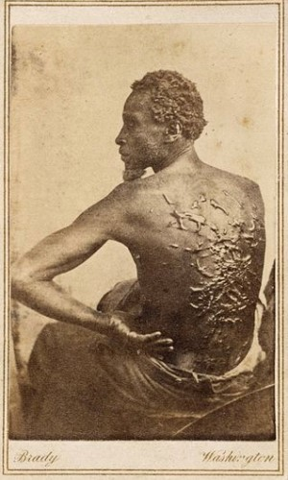
[1] When the Revolutionary War for American Independence from England broke out, the ideals of the new republic clashed with one of its foundational institutions: slavery. Life, liberty and the pursuit of happiness simply did not seem consistent with the practice of chattel slavery. rights, yet maintain the brutal practice of How could a group of people feel so passionate about these unalienable human bondages? Somehow slavery would manage to survive the revolutionary era, but great changes were brought to this peculiar institution, nevertheless.
The world's first antislavery society was founded in 1775 by Quakers in Philadelphia, the year the Revolution began. By 1788, at least thirteen of these clubs were known to exist in the American colonies. Some Northern states banned slavery outright, and some provided for the gradual end of slavery. At any rate, the climate of the Revolution made the institution unacceptable in the minds of many Northerners, who did not rely on forced labor as part of the economic system. Northerners did not, however, go as far as to grant equal rights to freed blacks. Nonetheless, this ignited the philosophical debate that would be waged throughout the next century.

"Medical examination photo of Gordon" by Mathew Brady is in the public domain.
Many slaves achieved their freedom during the Revolution without formal emancipation. The British army, eager to destroy the colonial economy, freed many slaves as they moved through the American South. Many slaves in the North were granted their freedom if they agreed to fight for the American cause. Although a clear majority of African Americans remained in bondage, the growth of free black communities in America was greatly fostered by the War for American Independence. Revolutionary sentiments led to the banning of the importation of slaves in 1807.
Slavery did not end overnight in America. Before any meaningful reform could happen, people needed to recognize that the economic benefit was vastly overshadowed by the overwhelming repugnance,immorality, and inhumanity of slavery.
[5] As the cotton industry grew and slavery became more and more entrenched across the American South, opposition to it also grew.
The first widely accepted solution to the slavery question in the 1820s was colonization. In effect, supporters of colonization wanted to transplant the slave population back to Africa. Their philosophy was simple: slaves were brought to America involuntarily. Why not give them a chance to enjoy life as though such a forced migration had never taken place? Funds were raised to transport freed AfricanAmericans across the Atlantic in the opposite direction. The nation of Liberia was created as a havenfor former American slaves.
But most African-Americans opposed this practice. The vast majority had never set foot on African soil. Many African-Americans rightly believed that they had helped build this country and deserved to live as free citizens of America. By the end of the decade, a full-blown Abolitionist movement¹¹ was born. ;
These new Abolitionists were different from their forebears. They were more radical than members of
the early antislavery societies. Past Abolitionists had called for a gradual end to slavery. They supported compensation to owners of slaves for their loss of property. They raised money for the purchase of slaves to grant freedom to selected individuals.
The new Abolitionists thought differently. They saw slavery as a blight on America that must be brought to an end immediately and without compensation to owners. They sent petitions to Congress and the states, campaigned for office, and flooded the South with inflammatory literature.
[10] Needless to say, they raised eyebrows throughout the North and the South. Soon, the battle lines were drawn. President Andrew Jackson banned the post office from delivering Abolitionist literature in the south. A "gag rule” was passed on the floor of the House of Representatives forbidding the discussion of bills that restricted slavery. Abolitionists were physically attacked because of their outspoken antislavery views. While northern churches rallied to the Abolitionist cause, the churches of the South used the Bible to defend slavery.
Abolitionists were always a minority, even on the eve of the Civil War. Their dogged determination to end human bondage was a struggle that persisted for decades. While mostly peaceful at first, abolitionists and their opponents began to trade violence as each side became more and more firmly rooted in its beliefs. Another seed of sectional conflict had been deeply planted in America’s psyche.¹⁶
"The Revolutionary Rise of Abolitionists", © 2016, CC By 4.0. Reprinted with permission, all rights reserved.

Unit 1: “The Revolutionary Rise of Abolitionism” https://www.commonlit.org/en/texts/the-revolutionary-rise-of-abolitionists
- What is abolitionism? Abolitionism is the historical movement to end the slave trade and set slaves free. When did Abolitionism reach its height? It reached its height during the Civil War.
- Why is the concept of slavery inconsistent with the American ideals of “Life, liberty, and the pursuit of happiness’? Many slave owners prohibited their slaves from having minor hobbies, such as reading, which goes against pursuit of happiness. Slaves are generally bounded to their master’s home, in fear of getting beat for trying to escape. That goes against liberty. A lot of slaves are not given the right nutrition daily, which goes against life.
- Who founded the world’s first anti-slavery society? Quakers in Philadelphia
- How does the American Revolution relate to the outlawing of slavery (specifically in the North)? The North was fighting to abolish slavery since it wasn’t really a factor to their agricultural society.
- How did some slaves earn their freedom during the American Revolution? They fought in the war.
- Why were some people in America in the early 1800s opposed to abolitionism? They felt that the Southern economy would plummet severely since forced labor was their only means of making money.
- What are the economic advantages and disadvantages of slavery according to the text? Some economic advantages were that a lot of businesses the South relied on started to grow, like the cotton industry. Also, they were able to raise money to compensate slave owners in the exchange for the freedom of certain individuals. Some disadvantages were that black people were never treated with the same respected as everyone else. For the most part, the text seems like it is emphasizing that there were no real draw backs economically on slavery.

Name: Class: The Wounded Knee Massacre
By Digital History 2016
The American Indian Wars were a series of armed conflicts between Native Americans, European colonists, and eventually American settlers. The Wounded Knee Massacre is widely regarded as the final conflict of these extended wars, occurring on the Lakota Pine Ridge Indian Reservation on December 29, 1890. The massacre was a result of increasing tension and fear between the United States government and the Sioux (The Great Sioux Nation, or Očhéthi Šakówiŋ, consists of Eastern Dakota, Western Dakota, and Lakota tribes). While specific details of the massacre are debated, the events of that day further soured relations between the United States and Native Americans, as well as resulted in excessive loss of life. In the first section of the text, the author provides a brief overview of the Wounded Knee Massacre. In the second part of the text, several individuals share their perspective on the massacre. Their testimony has been organized based on the chronology of the events that took place. As you read, take note of how the different perspectives explored in the text impact your understanding of the Wounded Knee Massacre.
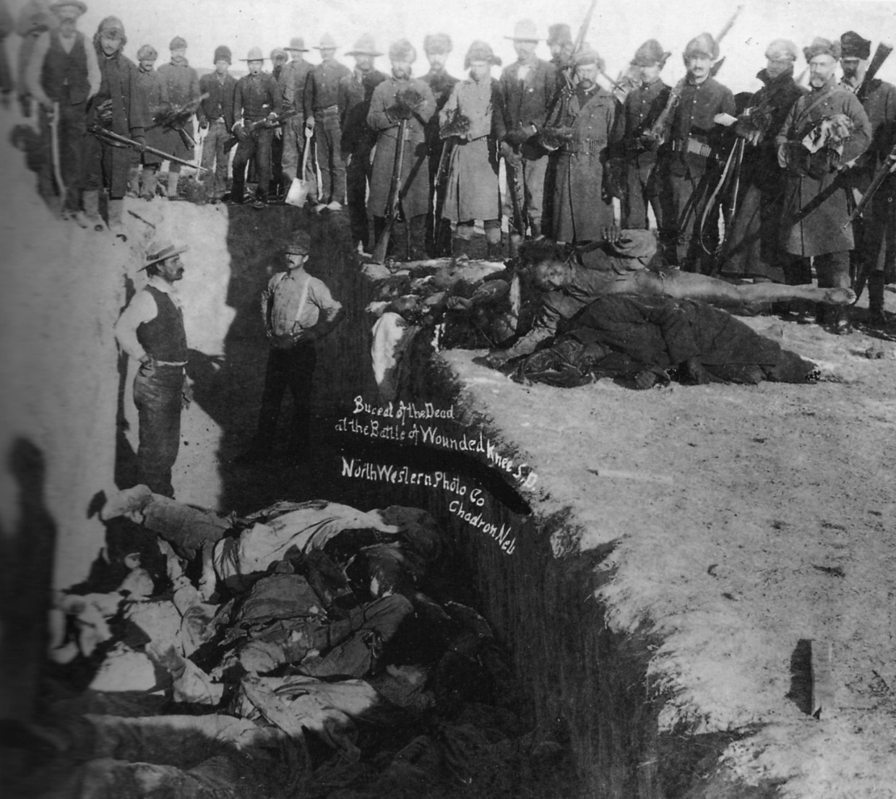
[1] The late nineteenth century marked the nadir of Indian life. Deprived of their homelands, their revolts suppressed, and their way of life besieged, many Plains Indians dreamed of restoring a vanished past, free of hunger, disease, and bitter warfare. Beginning in the 1870s, a religious movement known as the Ghost Dance arose among Indians of the Great Basin, and then spread, in the late 1880s, to the Great Plains. Beginning among the Paiute Indians of Nevada in 1870, the Ghost Dance promised to restore the way of life of their ancestors.
During the late 1880s, the Ghost Dance had great appeal among the Sioux, despairing over the death of a third of their cattle by disease and
angry that the federal government had cut their "Wounded Knee 1891domain. " by Northwestern Photo Co. is in the public food rations. In 1889, Wovoka, a Paiute holy man
from Nevada, had a revelation. If only the Sioux would perform sacred dances and religious rites, then the Great Spirit would return and raise the dead, restore the buffalo to life, and cause a flood that would destroy the whites.
Wearing special Ghost Dance shirts, fabricated from white muslin and decorated with red fringes and painted symbols, dancers would spin in a circle until they became so dizzy that they entered into a trance. White settlers became alarmed: “Indians are dancing in the snow and are wild and crazy...We need protection, and we need it now.”
Fearful that the Ghost Dance would lead to a Sioux uprising, army officials ordered Indian police to arrest the Sioux leader Sitting Bull. When Sitting Bull resisted, he was killed. In the ensuing panic, his followers fled the Sioux reservation. Federal troops tracked down the Indians and took them to a cavalry camp on Wounded Knee Creek. There, on December 29, 1890, one of the most brutal incidents in American history took place. While soldiers disarmed the Sioux, someone fired a gun. The soldiers responded by using machine guns to slaughter at least 146 Indian men, women, and children. Some historians believe the actual number of Indians killed was closer to 300. The Oglala Sioux spiritual leader Black Elk summed up the meaning of Wounded Knee:
[5] I can see that something else died there in the bloody mud and was buried in the blizzard. A people’s dream died there.
General Nelson Miles, who commanded military forces in the area, sought a court martial for the office in charge of the troops at Wounded Knee. Miles described what happened as a “cruel and unjustifiable massacre.”
While serving as the editor and publisher of the Aberdeen, South Dakota Saturday Pioneer, L. Frank
Baum, the author of The Wonderful Wizard of Oz, wrote an editorial following the death of Sitting Bull. “The Whites, by law of conquest, by justice of civilization, are masters of the American continent,” he wrote, “and the best safety of the frontier settlers will be secured by the total annihilation of the few remaining Indians.”
The Battle of Wounded Knee marked the end of three centuries of bitter warfare between Indians and whites. Indians had been confined to small reservations, where reformers would seek to transform them into Christian farmers. In the future, the Indian struggle to maintain an independent way of life and a separate culture would take place on new kinds of battlefields.

First Hand Accounts of the Massacre
Commanding General Nelson A. Miles: “The difficult Indian problem cannot be solved permanently at this end of the line. It requires the fulfillment of Congress of the treaty obligations which the Indians were entreated and coerced into signing… Congress has been in session now for several weeks, and could in a single hour confirm the treaty and appropriate the funds for its fulfillment; and, unless the officers of the army can give positive assurance that the Government intends to act in good faith with these people, the loyal element will be diminished, and the hostile element increased.”
[10] Black Elk, Lakota: “… My people looked pitiful. There was a big drought, and the rivers and creeks seemed to be dying. Nothing would grow that the people had planted, and the Wasichus had been sending less cattle and other food than ever before. The Wasichus had slaughtered all the bison and shut us up in pens. It looked as if we might all starve to death. We could not eat lies, and there was nothing we could do….”
L. Frank Baum Editor and Publisher, The Aberdeen Saturday Pioneer December 1890: “Sitting Bull, most renowned Sioux of modern history, is dead. He was an Indian with a white man’s spirit of hatred and revenge for those who had wronged him and his… With his fall the nobility of the Redskin is extinguished and what few are left are a pack of whining curs who lick the hand that smites them. The Whites, by law of conquest, by justice of civilization, are masters of the American continent, and the best safety of the frontier settlements will be secured by the total annihilation of the few remaining Indians….”
Commanding General Nelson A. Miles: “I was in command when what is known as the Messiah Craze and threatened uprising of the Indians occurred… During this time the tribe, under Big Foot, moved from their reservation to near Red Cloud Agency in South Dakota under a flag of truce. They numbered over 400 souls. They were intercepted by a command under Lt. Col. Whiteside, who demanded their surrender, which they complied with, and moved that afternoon some two or three miles and camped where they were directed to do, near the camp of the troops.”
Black Elk, Lakota: “It was now near the end of the Moon of Popping Trees and I was 27 years old. (December 1890) We heard that Big Foot was coming down from the Badlands with nearly four hundred people. Some of these were from Sitting Bull’s band. They had run away when Sitting Bull was killed, and joined Big Foot on Good River. There were only about a hundred warriors in his band, and all the others were women and children and some old men. They were all starving and freezing, and Big Foot was so sick that they had to bring him along in a pony drag. When they crossed Smoky Earth River, they followed up Medicine Root Creek to its head. Soldiers were over there looking for them. The soldiers had everything and were not freezing and starving. Near Porcupine Butte the soldiers came up to the Big Foots, and they surrendered and went along with the soldiers to Wounded Knee Creek.”
Commanding General Nelson A. Miles: “During the night Colonel Forsyth joined the command with reinforcements of several troops of the 7th Calvary. The next morning he deployed his troops around the camp, placed two pieces of artillery in position, and demanded the surrender of the arms of the warriors. This was complied with by the warriors going out from camp and placing the arms on the ground where they were directed. Chief Big Foot, an old man, sick at the time and unable to walk, was taken out of a wagon and laid on the ground.”
[15] Dewey Beard, Lakota: “… I did not sleep that night – did not lie down till morning – was afraid – could not rest or be quiet or easy. There was great uneasiness among the Indians all night; they were up most of the night – were fearful that they were to be killed….”
Philip F. Wells, Interpreter for General Forsyth: “I was interpreting for General Forsyth… The captured Indians had been ordered to give up their arms, but Big Foot replied that his people had no arms. Forsyth said to me, ‘Tell Big Foot he says the Indians have no arms, yet yesterday they were well armed when they surrendered. He is deceiving me. Tell him he need have no fear in giving up his arms, as I wish to treat him kindly…’ Big Foot replied, ‘They have no guns, except such as you have found. I collected all my guns at the Cheyenne River Agency and turned them in. They were all burned.’ They had about a dozen old-fashioned guns, tied together with strings – not a decent one in the lot….” Joseph Horn Cloud, Lakota: “While this was going on, the same officers said to the Indians, ‘I want you all to stand in a rank before the officers… I want the same number of soldiers to stand in front of the Indians and take the cartridges out of the guns and cock them and aim at their foreheads and pull the triggers. After this you will be free.’ Some of the Indians were getting wild at such talk and some said, ‘Now he sees that we have nothing in our hands, so he talks this way.’ Others said, ‘We are not children to be talked to like this.’ A man cried out:’ Take courage! Take courage!’ Big Foot spoke up, ‘Yes, take courage. There are too many children and old people.’”
Philip F. Wells, Interpreter for General Forsyth: “During this time a medicine man, gaudily dressed and fantastically painted, executed the maneuvers of the ghost dance, raising and throwing dust into the air. He exclaimed, ‘Ha! Ha! as he did so, meaning he was about to do something terrible, and said, I have lived long enough,’ meaning he would fight until he died. Turning to the young warriors, who were squatted together, he said, ‘Do not fear, but let your hearts be strong. Many soldiers are about us and have many bullets, but I am assured their bullets cannot penetrate us. The prairie is large, and their bullets will fly over the prairies and will not come toward us. If they do come toward us, they will float away like dust in the air.’ Then the young warriors exclaimed, ‘How!’ with great earnestness, meaning they would back the medicine man… Whiteside then said to me, ‘Tell the Indians it is necessary they be searched one at a time.’ The old Indians assented willingly by answering, ‘How!’ and the search began. The young warriors paid no attention to what I told them, but the old men – five or six of them – sitting next to us, passed through the lines and submitted to search.”
Dewey Beard, Lakota: “…Most of the Indians had given up their arms; there were a few standing with their guns, but the soldiers had not been to them. The knives were piled up in the center of the council; some young men had their guns and knives, but they had not been asked yet for them. There was a deaf Indian named Black Coyote who did not want to give up his gun; he did not understand what they were giving up their arms for… The struggle for the gun was short, the muzzle pointed upward toward the east and the gun was discharged. In an instant a volley followed as one shot, and the people began falling….”
[20] Philip F. Wells, Interpreter for General Forsyth: “…I heard someone on my left exclaim, ‘Look out! Look out!’ Turning my head and bringing my arms to port, I saw five or six young warriors cast off their blankets and pull guns out from under them and brandish them in the air. One of the warriors shot into the soldiers, who were ordered to fire into the Indians… I heard a shot from the midst of the Indians. As I started to cock my rifle, I looked in the direction of the medicine man. He or some other medicine man approached to within three or four feet of me with a long cheese knife, ground to a sharp point and raised it to stab me. The fight between us prevented my seeing anything else at the time. He stabbed me during the melee and nearly cut off my nose. I held him off until I could swing my rifle to hit him, which I did. I shot and killed him in self-defense and as an act of war as soon as I could gain room to aim my rifle and fire….”
Charles W. Allen, Editor of Chadron Democrat: “… The fighting continued for about half an hour, then was continued in skirmish for another hour. When the smoke cleared away from in front of the tent where it began, there were 45 dead Indians with their impregnable ghost shirts on laying dead on a space of ground about 200 yards in diameter.”
Dewey Beard, Lakota: “…I was badly wounded and pretty weak too. While I was lying on my back, I looked down the ravine and saw a lot of women coming up and crying. When I saw these women, girls and little girls and boys coming up, I saw soldiers on both sides of the ravine shoot at them until they had killed every one of them… Going a little further, (I) came upon my mother who was moving slowly, being very badly wounded… When (I) caught up to her, she said, ‘My son, pass by me; I am going to fall down now.’ As she went up, soldiers on both sides of the ravine shot at her and killed her… (I) heard the Hotchkiss or Gatling guns shooting at them along the bank. Now there went up from these dying people a medley of death songs that would make the hardest heart weep. Each one sings a different death song if he chooses. The death song is expressive of their wish to die. It is also a requiem for the dead. It expresses that the singer is anxious to die too….”
American Horse, Lakota: “There was a woman with an infant in her arms who was killed as she almost touched the flag of truce… A mother was shot down with her infant; the child not knowing what its mother was dead was still nursing… The women as they were fleeing with their babies were killed together, shot right through… and after most all of them had been killed a cry was made that all those who were not killed or wounded should come forth and they would be safe. Little boys… came out of their places of refuge, and as soon as they came in sight a number of soldiers surrounded them and butchered them.”
Thomas H. Tibbles, Omaha World Herald: “Though the active attack lasted perhaps twenty minutes, the firing continued for an hour or two, whenever a soldier saw a sign of life. Indian women and children fled into the ravine to the south, and some of them on up out of it across the prairie, but the soldiers followed them and shot them down mercilessly.”
[25] Corporal Paul H. Weinert (Awarded Medal of Honor for role at Wounded Knee): “They kept yelling at me to come back, and I kept yelling for a cool gun – there were three more on the hill not in use. Bullets were coming like hail from the Indians’ Winchesters. The wheels of my gun were bored full of holes and our clothing was marked in several places. Once a cartridge was knocked out of my hand just as I was about to put it in the gun, and it’s a wonder the cartridge didn’t explode. I kept going in farther, and pretty soon everything was quiet and at the other end of the line.”
Cavalryman: “Slowly, for the sake of the wounded, the long column left the battlefield where the reds were lying as dark spots in the winter night and their sign of peace, the white flag, was moving gently with the wind.”
Black Elk, Lakota: “It was a good winter day when all this happened. The sun was shining. But after the soldiers marched away from their dirty work, a heavy snow began to fall. The wind came up in the night. There was a big blizzard, and it grew very cold. The snow drifted deep in the crooked gulch, and it was one long grave of butchered women and children and babies, who had never done any harm and were only trying to run away.”
Commanding General Nelson A. Miles: “…A detachment of soldiers was sent into the camp to search for any arms remaining there, and it was reported that their rudeness frightened the women and children. It was also reported that a remark was made by one of the soldiers that “when we get the arms away from them we can do as we please with them,” indicating that they were to be destroyed. Some of the Indians could understand English. This and other things alarmed the Indians and [a] scuffle occurred between one warrior who had [a] rifle in his hand and two soldiers. The rifle was discharged and a massacre occurred, not only the warriors but the sick Chief Big Foot, and a large number of women and children who tried to escape by running and scattering over the prairie were hunted down and killed.”
Thomas H. Tibbles, Omaha World Herald: “Nothing I have seen in my whole… life ever affected or depressed or haunted me like the scenes I saw that night in that church. One un-wounded old woman… held a baby on her lap… I handed a cup of water to the old woman, telling her to give it to the child, who grabbed it as if parched with thirst. As she swallowed it hurriedly, I saw it gush right out again, a bloodstained stream, through a hole in her neck.” Heartsick, I went to… find the surgeon… For a moment he stood there near the door, looking over the mass of suffering and dying women and children… The silence they kept was so complete that it was oppressive… Then to my amazement I saw that the surgeon, who I knew had served in the Civil War, attending the wounded… from the
Wilderness to Appomattox, began to grow pale… ‘This is the first time I’ve seen a lot of women and children shot to pieces,’ he said. ‘I can’t stand it’…. Out at Wounded Knee, because a storm set in, followed by a blizzard, the bodies of the slain Indians lay untouched for three days, frozen stiff from where they had fallen. Finally they were buried in a large trench dug on the battlefield itself. On that third day Colonel Colby… saw the blanket of a corpse move… Under the blanket, snuggled up to its dead mother, he found a suckling baby girl.”
[30] Commanding General Nelson A. Miles, Army investigations of Wounded Knee: “I would like to send a delegation to Washington to receive assurance of the higher authority of good intentions of the Government towards them. This will answer a double purpose, namely, satisfy them, bridge over the transition period between war and peace, dispel distrust and hostility, and restore confidence; it will also be a guarantee of peace while they are absent.”
Black Elk, Lakota: “I did not know then how much was ended. When I look back now from this high hill of my old age, I can still see the butchered women and children lying heaped and scattered along the crooked gulch as plain as when I saw them with eyes still young. And I can see that something else died there in the bloody mud, and was buried in the blizzard. A people’s dream died there. It was a beautiful dream…”
Source: Personal accounts of Wounded Knee taken from interviews by Eli S. Ricker, Black Elk Speaks as well as reports and testimony relating to the Army investigation of the Battle of Wounded Knee and the Sioux Campaign of 1890-91.
“The Wounded Knee Massacre ” from http://www.digitalhistory.uh.edu/disp_textbook.cfm?smtID=3&psid=1101, © 2016, Used with Permission. Reprinted with permission, all rights reserved.

Unit 2: “The Wounded Knee Massacre” https://www.commonlit.org/en/texts/the-wounded-knee-massacre
- What was the Wounded Knee Massacre? It was a bloody massacre of around 150 Indians at the site of Wounded Knee.
- What caused the Wounded Knee Massacre? While the army soldiers were disarming the Sioux, someone’s gun fired off. The army took that as the Sioux trying to sneak shots in, so they rapidly fired back with their machine guns.
- What was the result of the Wounded Knee Massacre? 146 Indian men, women, and children were slaughtered that day.
- Why did Native Americans practice the Ghost Dance? It promised a restoration of the way their ancestors lived in the past.
- Give two reasons the Sioux were angry and worried about their future? The federal government cut off their rations and their cattle were dying.
- Why was Sitting Bull arrested? Army officials feared that the Ghost Dance would cause a Sioux uprising, so they arrested the leader being Sitting Bull.
- Why did General Nelson seek a court martial for US Army troops involved in the Wounded Knee Massacre? He wanted the troops trialed for causing a “cruel and unjustifiable” massacre, as he described it to be in the text.
- How did the massacre end the Indian Wars? It ended 3 centuries of bitter warfare between the Indians and the whites. Indians ended up being confined to small reservations, where reformers sought to turn them into Christian farmers.

. “Chattel slavery” is when an enslaved person is owned forever and whose direct descendants are automatically enslaved.
2. rights that cannot be taken away or denied
3. A “Quaker” is a member of the Religious Society of Friends, a Christian movement devoted to peaceful principles.
4. Emancipation (noun): the fact or process of being set free from legal, social, or political restrictions
5. Sentiment (noun): a view or attitude toward a situation or event; an opinion
6. Repugnance (noun): intense disgust
7. Entrench (adjective): firmly established and difficult or unlikely to change
8. Transplant (verb): move or transfer something to another place or situation
9. a country on the West African coast
. Haven (noun): a place of safety 11. a movement to end slavery
2. A “blight” refers to a disease or flaw.
3. Inflammatory (adjective): tending to arouse anger, hostility, passion
4. Dogged (adjective): determined to do something, even if it is very difficult
. Persist (verb): to continue to occur or exist beyond the usual, expected, or normal time 16. the human soul, mind, or spirit
1. Muslin is a cotton fabric or plain weave.
2. The part of the military force made up of troops that serve on horseback.
3. The government used Gatling guns, which were early hard-cranked forerunners of machine guns.
. A “court martial” is a judicial court for trying a member of the armed services of offenses against military law. Miles' pursuit of a court martial ended in a comprehensive Army Court of Inquiry, which is not a formal court-martial. The Court of Inquiry criticized Forsynth for his tactics but did not hold him responsible.
5. This is a term used by the Lakota to describe the first European people, meaning “takes the fat,” or “greedy person.”
6. A “cur” is an aggressive dog or one that is in poor condition.
7. Short for “lieutenant colonel.”
8. Gaudily (adjective): brilliantly or excessively showy
9. A “volley” is a number of bullets, arrows, or other projectiles discharged at one time.
0. Melee (noun): a confused fight or scuffle
1. “Impregnable” means “unable to be defeated or destroyed.”
. A gun that as mounted on a light carriage or packed on two mules, intended to accompany an army traveling in rough country.
3. A rapid fire, hand cranked weapon that was the forerunner of the machine gun.
4. A “requiem” is something that resembles a solemn chant.
5. The Battle of the Wilderness was fought May 5-7, 1864, in the Wilderness of Spotsylvania, Virginia.
6. One of the last battles of the American Civil War.
7. A gulch is a narrow ravine or canyon formed by running water.

